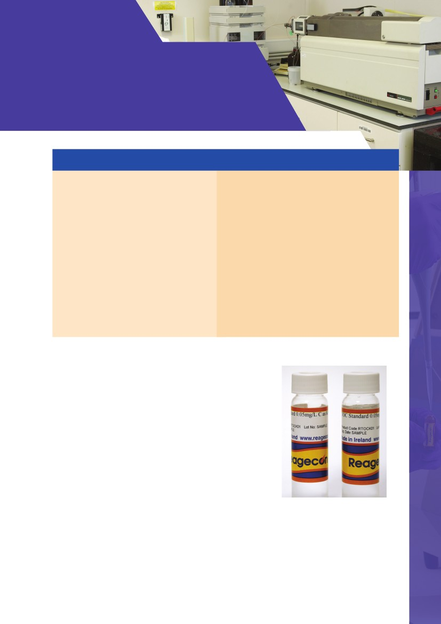
TOC/TIC Standards
- Premium Range
Summary of Features & Benefits:
Commercial Benefits
• Extensive range (500ppb to 20,000ppm /0.5mg/l
to 20,000mg/l)
• Presented in single - use glass vials
• Extended shelf life
• Ready to Use
• Offered as single vials or convenient kit format
Technical Benefits
• In accordance with USP <643> and <1051> guidelines
• Consistency of product - Independent, Traceable,
Certified
• Certificates of Analysis and Safety Data Sheets available
online
• Extremely high specification and purity
• Manufactured in a cleanroom environment
• Vials are manufactured, cleaned and leached specifically
for low level TOC standards
• Products manufactured from Ultra-Pure Water,
produced by a special proprietary process
• ISO/IEC 17025 Accreditation 500µg/L to 50mg/l (INAB
Ref:264T)
Reagecon manufactures a range of Total Organic Carbon (TOC) and Total
Inorganic Carbon (TIC) Standards for ease of use when calibrating all types of
TOC analysers, irrespective of brand. All of our TOC standards are manufactured
using high purity raw materials in accordance with USP <1051> and <643>
guidelines. These products are prepared gravimetrically on a weight/weight
basis. Both solute (salts) and solvent (water) are weighed on a balance calibrated
by Reagecon engineers using OIML traceable weights. Reagecon holds ISO/IEC
17025 accreditation for calibration of laboratory balances (INAB Ref:265C). The
resulting Balance Certificate of Calibration is issued in accordance with the
requirements of ISO/IEC 17025. The TOC / TIC of the standard is verified using
a high performance calibrated TOC analyser. The calibration of this instrument
involves the use of high purity ISO Guide 34 accredited TOC standards similar
in TOC value to the products listed in the following tables.
147

TOC/TIC Standards
Product No.
RTOCW
RTOCRs
RTOCRss
RTOCK08
RTOCK09
RTOCK10
RTOCK10a
RTOCK11
RTOCK12
RTOCK30
RTOCK13
RTOCK14
RTOCK15
RTOCK16
RTOCK17
RTOC125B
RTOC125S
RTOCK18
RTOC1000K
RTOCK19
RTOCK20
RTOCK01
RTOC200
RTOC800
RTICN01
RTICN02
RTICN03
RTICN04
RTICN09
RTICN05
RTICN06
RTICN07
RTICN08
RTIC1000
RTOCS01
RTOCS02
RTOCS03
RTOCS04
RTOCS05
RTOCS06
RTOCS07
RTOCS08
RTOCS09
RTOCS10
RTOCS11
Description
USP Reagent Water Rw
USP Standard Sucrose Solution Rs (0.5mg/L C)
USP System Suitability Solution 1, 4-Benzoquinone (0.5mg/L C)
TOC Standard 0.5mg/L C as Potassium Hydrogen Phthalate
TOC Standard 1.0mg/L C as Potassium Hydrogen Phthalate
TOC Standard 1.5mg/L C as Potassium Hydrogen Phthalate
TOC Standard 1.5mg/L C as Potassium Hydrogen Phthalate
acidified with Hydrochloric Acid
TOC Standard 10mg/L C as Potassium Hydrogen Phthalate
TOC Standard 25mg/L C as Potassium Hydrogen Phthalate
TOC Standard 30 mg/L C as Potassium Hydrogen Phthalate
TOC Standard 50mg/L C as Potassium Hydrogen Phthalate
TOC Standard 5mg/L C as Potassium Hydrogen Phthalate
TOC Standard 2.5mg/L C as Potassium Hydrogen Phthalate
TOC Standard 4mg/L C as Potassium Hydrogen Phthalate
TOC Standard 100mg/L C as Potassium Hydrogen Phthalate
TOC Standard 125ppm C as 1,4-Benzoquinone
TOC Standard 125ppm C as Sucrose
TOC Standard 1,000mg/L C as Potassium Hydrogen Phthalate
TOC Standard 1,000ppm C as Potassium Hydrogen Phthalate
TOC Standard 5,000mg/L C as Potassium Hydrogen Phthalate
TOC Standard 20,000mg/L C as Potassium Hydrogen Phthalate
TOC Standard 50ppb C as Potassium Hydrogen Phthalate
TOC Standard 200ppb C as Sucrose
TOC Standard 800ppb C as Sucrose
TIC Standard 0.5mg/L as Sodium Carbonate
TIC Standard 1.0mg/L as Sodium Carbonate
TIC Standard 1.5mg/L as Sodium Carbonate
TIC Standard 2mg/L as Sodium Carbonate
TIC Standard 4mg/L as Sodium Carbonate
TIC Standard 5mg/L as Sodium Carbonate
TIC Standard 10mg/L as Sodium Carbonate
TIC Standard 25mg/L as Sodium Carbonate
TIC Standard 50mg/L as Sodium Carbonate
TIC Standard 1000mg/L as Sodium Carbonate
TOC Standard 0.5mg/L C as Sucrose
TOC Standard 1.0mg/L C as Sucrose
TOC Standard 2mg/L C as Sucrose
TOC Standard 5mg/L C as Sucrose
TOC Standard 10mg/L C as Sucrose
TOC Standard 25mg/L C as Sucrose
TOC Standard 50mg/L C as Sucrose
TOC Standard 0.25mg/L C as Sucrose
TOC Standard 0.75mg/L C as Sucrose
TOC Standard 4mg/L C as Sucrose
TOC Standard 500mg/L C as Sucrose
Pack Size
35ml
35ml
35ml
35ml
35ml
35ml
35ml
35ml
35ml
35ml
35ml
35ml
35ml
35ml
35ml
35ml
35ml
35ml
35ml
35ml
35ml
35ml
35ml
35ml
35ml
35ml
35ml
35ml
35ml
35ml
35ml
35ml
35ml
35ml
35ml
35ml
35ml
35ml
35ml
35ml
35ml
35ml
35ml
35ml
35ml
148

TOC/TIC Standards
Product No.
RTOCN01
RTOCN02
RTOCM01
RTOCWa
RTOCRsa
RTOCRssa
Description
TOC Standard 50mg/L C as Nicotinamide
TOC Standard 0.5mg/L C as Nicotinamide
TOC Standard 0.5mg/L C as Methanol
USP Reagent Water Rw acidified with HCl
USP Standard Sucrose Solution Rs (0.5mg/L C) acidified with HCl
USP System Suitability Solution 1,4-Benzoquinone (0.5mg/L C)
acidified with HCl
USP System Suitability Set consisting of 1 x 40ml vial of Reagent Water
(RTOCW), Standard Solution (RTOCRs) and Suitability Solution (RTOCRss)
2 x USP System Suitability Set consisting of 1 x 40ml vial of Reagent Water
(RTOCW), Standard Solution (RTOCRs) and Suitability Solution (RTOCRss).
Delivered at six month intervals
4 x USP System Suitability Sets, consisting of: 1 x 40ml vial of Reagent Water
(RTOCW), Standard Solution (RTOCRs) and Suitability Solution (RTOCRss).
Delivered at three month intervals
12 x (USP System Suitability Set consisting of 1 x 40ml vial of Reagent Water
(RTOCW), Standard Solution (RTOCRs) and Suitability Solution (RTOCRss).
Delivered at monthly intervals
52 x (USP System Suitability Set consisting of 1 x 40ml vial of Reagent Water
(RTOCW), Standard Solution (RTOCRs) and Suitability Solution (RTOCRss).
Delivered at 2 weekly intervals
260 x USP System Suitability Set consisting of 1 x 40ml vial of Reagent Water
(RTOCW), Standard Solution (RTOCRs) and Suitability Solution (RTOCRss).
Delivered at 2 weekly intervals
Carbon Calibration Set 1-50mg/L C consisting of 1 x 40ml vial each of
calibration blank (RTOCW), TOC Standards 1(RTOCK09), 5 (RTOCK14), 10
(RTOCK11), 25 (RTOCK12), 50 (RTOCK13) mg/L C as Potassium Hydrogen
Phthalate, TIC Standards 1mg/L (RTICN02), 5mg/L (RTICN05), 10mg/L
(RTICN06), 25mg/L (RTICN07), 50mg/L (RTICN08) C as Sodium Carbonate
1mg C/L Carbon Standard Set consisting of 1 x 40ml vial each of calibration
blank (ROTCW), 1mg/L (RTOCK09) C TOC as Potassium Hydrogen Phthalate and
1 mg/L (RTICN02) C TIC as Sodium Carbonate
1mg C/L Carbon Verification Set consisting of 1 x 40ml vial each of calibration
blank (ROTCW), 1mg/L (RTOCS02) C TOC as Sucrose and 1 mg/L (RTICN02) C
TIC as Sodium Carbonate
1mg C/L Carbon Standard Set and Verification Set consisting of 1 x RC120002
and 1 x RC120003
5mg C/L Carbon Standard Set consisting of 1 x 40ml vial each of calibration
blank (RTOCW), 5mg/L (RTOCK14) C TOC as Potassium Hydrogen Phthalate and
5 mg/L (RTCIN05) C TIC as Sodium Carbonate
5mg C/L Carbon Verification Set consisting of 1 x 40ml vial each of calibration
blank (RTOCW), 5mg/L (RTOCS04) TOC C as Sucrose and 5 mg/L (RTICN05) TIC
C as Sodium Carbonate
5mg C/L Carbon Standard and Verification Set consisting of 1 x RC120005 and 1
x RC120006
Pack Size
35ml
35ml
35ml
35ml
35ml
35ml
RTOCUSP1
3 x 35ml
RTOCUSP2
3 x 35ml
RTOCUSP4
3 x 35ml
RTOCUSP12
3 x 35ml
RTOCUSP52
3 x 35ml
RTOCUSP260
3 x 35ml
RC120001
11 x 35ml
RC120002
3 x 35ml
RC120003
3 x 35ml
RC120004
6 x 35ml
RC120005
3 x 35ml
RC120006
3 x 35ml
RC120007
6 x 35ml
149
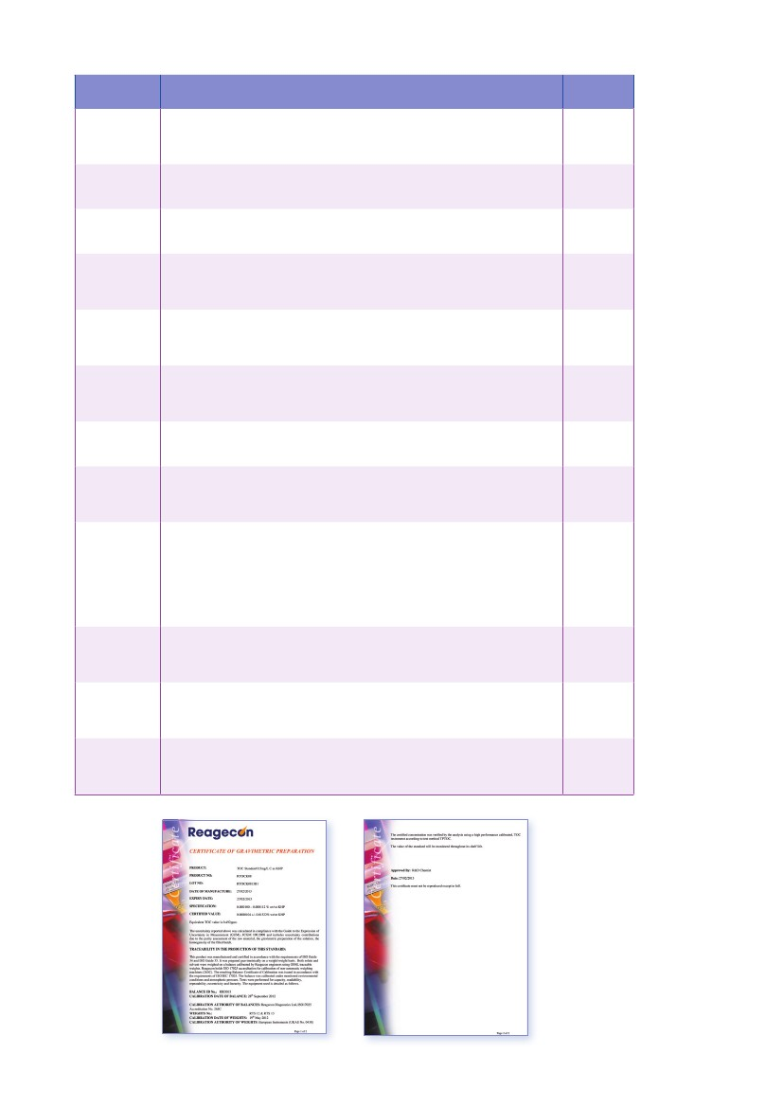
Product No.
RC120008
Description
0.5mg/L Carbon Verification Set consisting of 1 x 40ml vial each of calibration
blank (RTOCW), 0.5mg/L (RTOCS01) TOC C as Sucrose and 0.5mg/L (RTICN01)
TIC C as Sodium Carbonate
1mg/L Carbon Standard and 0.5mg/L Carbon Verification Set Consisting of 1 x
RC120002 and 1 x RC120008
Validation Set -- Accuracy Precision (0.5mg), consisting of 1 x Reagent water
(RTOCW) and 1 x 0.5mg/L C as sucrose (RTOCS01) in 40ml Vials
Validation Set -- Linearity, consisting of 1x Reagent water blank (RTOCW) and 1
each of 0.25mg/L (RTOCS08), 0.5mg/L (RTOCS01), 0.75mg /L (RTOCS09),
C as Sucrose in 40ml vials
Validation Set -- Specificity, consisting of 1 x Reagent water (RTOCW), 1 x
0.5mg/L (RTOCM01) C as Methanol, 1 x 0.5mg/L (RTOCN02) C as Nicotinamide
and 1 x 0.5mg/L (RTOCK08) C as Potassium Hydrogen Phthalate in 40ml vials
Validation Set -- Robustness Standards, consisting of 1 x Reagent water
(RTOCWa), 1 x Standard Solution (RTOCRsa), 1 x System suitability solution
(RTOCRssa) in 40ml vials. All standards in the set acidified
Validation Set -- Complete , consisting of 1xRC120010, 1xRC120011, RC120012
and RC120013
10mg C/L Carbon Standard Set consisting of 1 x 40ml vial each of calibration
blank (RTOCW), 10mg/L (RTOCK11) TOC C as Potassium Hydrogen Phthalate
and 10mg/L (RTICN06) TIC C as Sodium Carbonate
Multipoint calibration set for Sievers 5310C, consisting of 1 x calibration blank
(RTOCW), 1 each of 0.25mg/L (RTOCK15), 1mg/L (RTOCK09), 5mg/L (RTOCK14),
25mg/L (RTOCK12), 50mg/L (RTOCK13) C as Potassium Hydrogen Phthalate
TOC standards and 1 each of 1mg/L (RTICN02), 5mg/L (RTICN05), 10mg/L
(RTICN06), 25mg/L (RTICN07), 50mg/L (RTICN08) C as Sodium Carbonate
TIC standards
2mg C/L Carbon Verification Set consisting of 1 x 40ml vial each of calibration
blank (RTOCW), 2mg/L (RTOCS03) TOC C as Sucrose and 2mg/L (RTICN04) TIC
C as Sodium Carbonate
10mg C/L Carbon Verification Set consisting of 1 x 40ml vial each of calibration
blank (RTOCW), 10mg/L (RTOCS05) TOC C as Sucrose and 10mg/L (RTICN06)
TIC C as Sodium Carbonate
3 point Carbon Verification Set consisting of 1 x 40ml Vial each of 1mg/L
(RTOCK09), 5mg/L (RTOCK14), 10mg/L (RTOCK11) C as Potassium Hydrogen
Phthalate
Pack Size
3 x 35ml
RC120009
6 x 35ml
RC120010
2 x 35ml
RC120011
4 x 35ml
RC120012
4 x 35ml
RC120013
3 x 35ml
RC120014
13 x 35ml
RC120015
3 x 35ml
RC120016
11 x 35ml
RC120017
3 x 35ml
RC120018
3 x 35ml
RC120019
3 x 35ml
150
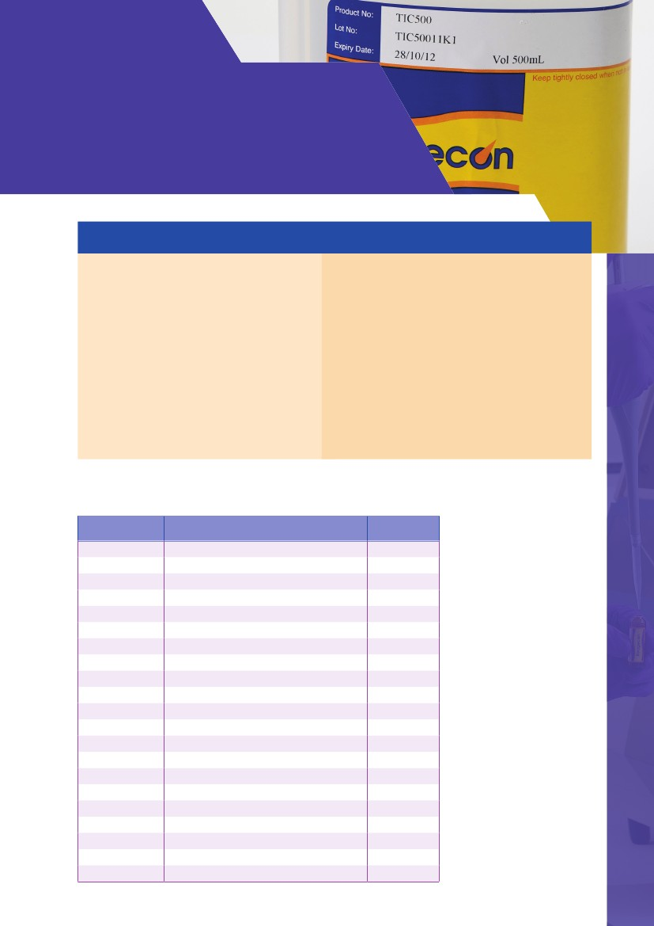
TOC/TIC Standards
- Quality Range
Summary of Features & Benefits:
Commercial Benefits
• Can be used with any brand of TOC analyser
• Extensive range (5ppm-5000ppm)
• Extended shelf life
• Ready to Use
• The Quality Range represents excellent value
for money
• Other TOC/TIC values can be quoted for upon
request
• Mixed TOC and TIC standards available as a
normal part of the range
Technical Benefits
• Consistency of product - Independent, Traceable,
Certified
• Certificates of Analysis and Safety Data Sheets
available online
• Presented in special 500ml twin neck bottles (all
values above 50ppm) - prevents product
contamination, evaporation or interference
• Twin neck bottles come with a special dosing device
• All values below 50ppm are packed in specially
cleaned and leached 500ml amber glass bottles
TOC Standards
Product No.
TOC5
TOC5W
TOC75
TOC10
TOC15
TOC20
TOC25
TOC30
TOC50
TOC50W
TOC60
TOC100
TOC160
TOC200
TOC250
TOC500
TOC750
TOC1M
TOC15M
TOC2M
TOC5M
Description
Total Organic Carbon Standard 5ppm
Total Organic Carbon Standard 5pm
Total Organic Carbon Standard 7.5ppm
Total Organic Carbon Standard 10ppm
Total Organic Carbon Standard 15ppm
Total Organic Carbon Standard 20ppm
Total Organic Carbon Standard 25ppm
Total Organic Carbon Standard 30ppm
Total Organic Carbon Standard 50ppm
Total Organic Carbon Standard 50ppm
Total Organic Carbon Standard 60ppm
Total Organic Carbon Standard 100ppm
Total Organic Carbon Standard 160ppm
Total Organic Carbon Standard 200ppm
Total Organic Carbon Standard 250ppm
Total Organic Carbon Standard 500ppm
Total Organic Carbon Standard 750ppm
Total Organic Carbon Standard 1000ppm
Total Organic Carbon Standard 1500ppm
Total Organic Carbon Standard 2000ppm
Total Organic Carbon Standard 5000ppm
Pack Size
500ml
2.5L
500ml
500ml
500ml
500ml
500ml
500ml
500ml
2.5L
500ml
500ml
500ml
500ml
500ml
500ml
500ml
500ml
500ml
500ml
500ml
151
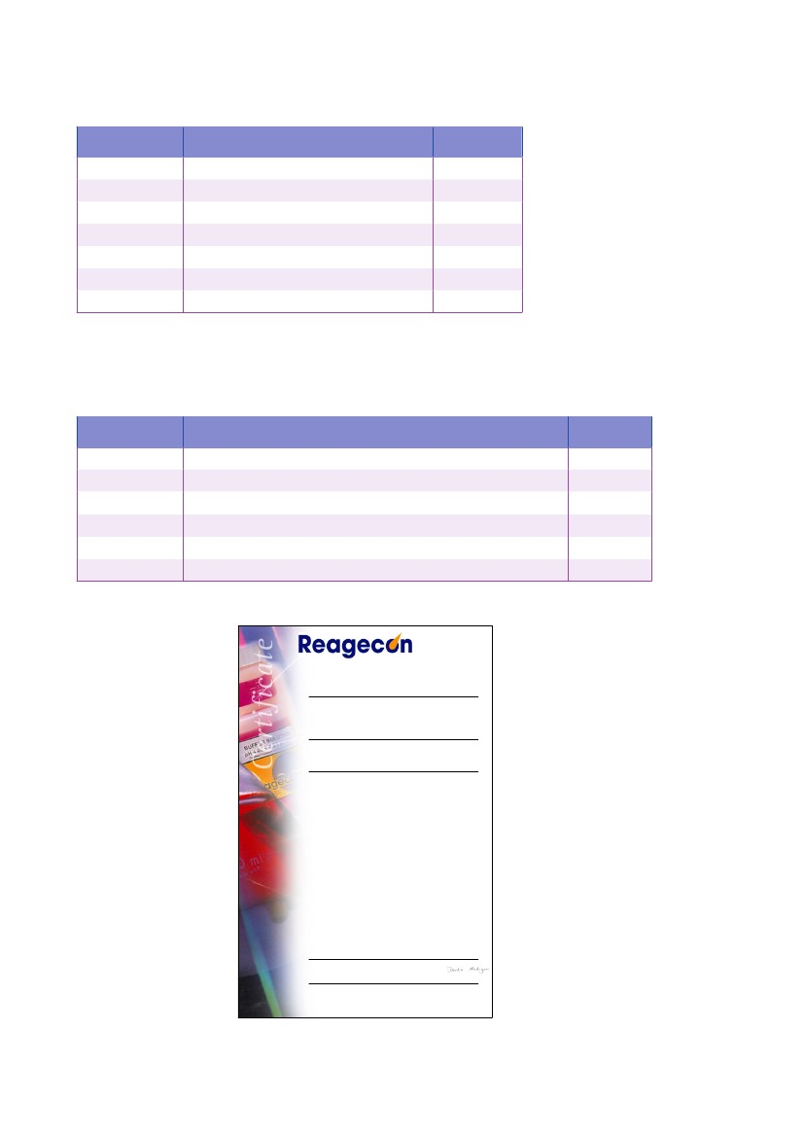
TIC Standards
Product No.
TIC5
TIC50
TIC100
TIC200
TIC500
TIC1M
TIC2M
Description
Total Inorganic Carbon Standard 5ppm
Total Inorganic Carbon Standard 50ppm
Total Inorganic Carbon Standard 100ppm
Total Inorganic Carbon Standard 200ppm
Total Inorganic Carbon Standard 500ppm
Total Inorganic Carbon Standard 1000ppm
Total Inorganic Carbon Standard 2000ppm
Pack Size
500ml
500ml
500ml
500ml
500ml
500ml
500ml
Mixed TOC/TIC Standards
Product No.
TOIC10
TOIC100
TOIC1M
TOIC2M
TOIC308
TOIC4M
Description
Mixed Standard (equal conc of organic & inorganic carbon) 10ppm
Mixed Standard (equal conc of organic & inorganic carbon) 100ppm
Mixed Standard (equal conc of organic & inorganic carbon) 1000ppm
Mixed Standard (equal conc of organic & inorganic carbon) 2000ppm
Mixed Standard 30ppm Organic Carbon, 8ppm Inorganic Carbon
Mixed Standard (equal conc of organic & inorganic carbon) 4000ppm
Pack Size
500ml
500ml
500ml
500ml
500ml
500ml
Certificate of Analysis
Carbon Standards
Total Organic Carbon 5ppm
Product No:
Lot No:
Expiry date:
Mean Assay:
Date of measurement:
Specification:
Method:
4.95 - 5.05ppm as TOC
TOC5
TOC516C1
28/03/2017
5.00 ppm as TOC
15/03/2016
Standardised in accordance with in-house method acidimetric.
Reference:
Vogels Textbook of Quantitative Inorganic Analysis. Fifth Edition.
Products are manufactured under an NSAI registered I.S EN ISO9001:2008 Quality System, registration no: 19.2769
Date of issue of the certificate:
15/03/2016
QC Technician Derdre Madigan
Complementary information relative to this product is available at www.reagecon.com
Page 1 of 1.This Certificate must not be reproduced except in full. Rev-16C10
Reagecon Diagnostics Ltd.
Shannon Free Zone, Shannon, Co. Clare, Ireland.
Tel +353 61 472622, Fax: +353 61 472642
Email: sales@reagecon.ie, www.reagecon.com
152
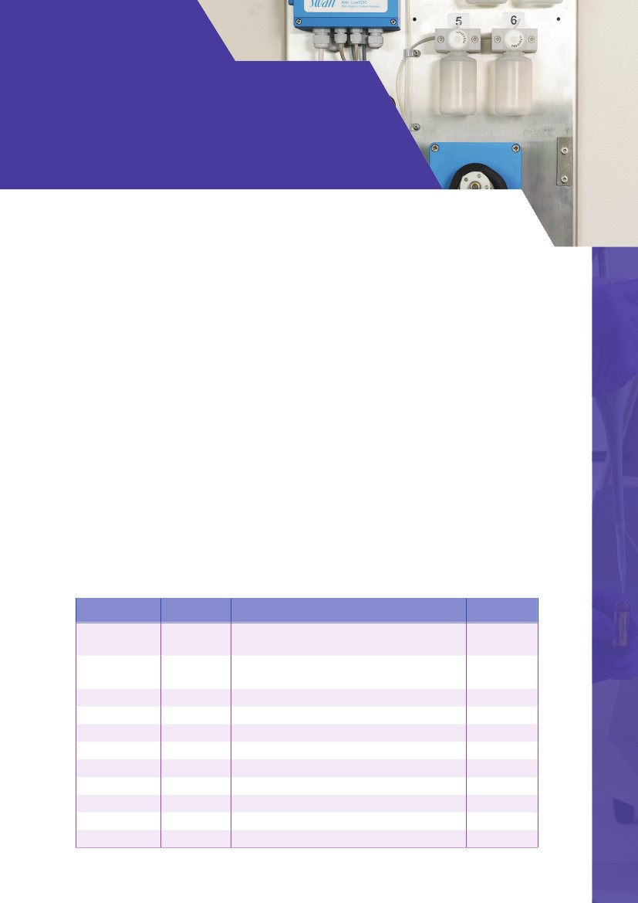
TOC/TIC Standards
- Instrument Specific
Reagecon’s Premium Range of TOC/TIC Standards as detailed in the second last chapter are an independent range
of standards suitable for use on the Sievers® Range of Laboratory TOC/TIC analysers (35ml vials). The Quality Range
as detailed in the previous chapter is suitable for other TOC/TIC analysers available in the market place.
Reagecon offer an extensive range of new independent standards, suitable for use on other leading brands of TOC/
TIC analysers for laboratory and online applications.
Although the range is not totally exhaustive it does include independent standards for Brands listed alphabetically
below such as;
• Analytik Jena®
• Anatel®
• OI Analytical®
• Shimadzu®
• Sievers®
• Teledyne Tekmar®
• Thornton®
These standards are developed, validated, manufactured and tested to an extremely high specification. We believe
that they offer real choice in the market place and represent exceptionally good value.
In addition to the products listed bulk sizes may be available upon request, please contact us with your request by
emailing sales@reagecon.ie
Instrument Specific TOC/TIC Standards
Instrument
Analytik Jena
Analytik Jena
Analytik Jena
Analytik Jena
Analytik Jena
Analytik Jena
Analytik Jena
Anatel A1000
Anatel A1000
Anatel A1000
Anatel A1000
Product
ISTOC1103
ISTOC1104
ISTOC1105
ISTOC1106
ISTOC1107
ISTOC1108
ISTOC1124
ISTOC1030
ISTOC1034
ISTOC1038
ISTOC1046
Description
System Suitability Set to USP; Reagent Water,
0.5mg/L C Sucrose and 0.5mg/L C 1,4- Benzoquinone
System Suitability Set to JP; Reagent Water,
0.5mg/L C Sodium Dodecylbenzene Sulfonate
USP Reagent Water
JP Reagent Water
0.5mg/L C from USP Sucrose
0.5mg/L C from USP 1,4 - Benzoquinone
0.5mg/L C from Sodium Dodecylbenzene Sulfonate
Calibration Blank
Calibration Standard 0.25 mg/L C NIST Sucrose
Calibration Standard 0.5 mg/L C NIST Sucrose
Calibration Standard 0.75 mg/L C NIST Sucrose
Pack Size
Kit (3x40ml)
Kit (2x40ml)
40ml
40ml
40ml
40ml
40ml
1L
1L
1L
1L
153

Instrument
Anatel A1000
Anatel A643
Anatel A643
Anatel A643
Product
ISTOC1165
ISTOC1016
ISTOC1079
ISTOC1080
Description
System Suitability Set to USP; Reagent Water, 0.5mg/L C
Sucrose and 0.5mg/L C 1,4- Benzoquinone
100uS/cm Conductivity Standard for Calibration
Calibration Blank
System Suitability Set; 2 x Reagent Water, 0.5mg/L C
USP Sucrose, 0.5mg/L C 1,4- Benzoquinone and
0.25mg/L C NIST Sucrose as Check
Calibration Standard 0.25 mg/L C NIST Sucrose
Calibration Standard 0.5 mg/L C NIST Sucrose
Calibration Standard 0.75 mg/L C NIST Sucrose
Validation Set; 2 x Blanks, 0.25 mg/L C NIST Sucrose, 0.5
mg/L C NIST Sucrose and 0.75 mg/L C NIST Sucrose
Validation Kit; 2 x Blanks and 0.5 mg/L C NIST Sucrose
Calibration Blank
Calibration Standard 0.25 mg/L C NIST Sucrose
Calibration Standard 0.5 mg/L C NIST Sucrose
Calibration Standard 0.75 mg/L C NIST Sucrose
USP Reagent Water System Suitability Standard
0.5mg/L C from USP Sucrose System
Suitability Standard
0.5mg/L C from USP 1,4 Benzoquinone System
Suitability Standard
USP System Suitability Set; Reagent Water, 0.5mg/L C
Sucrose and 0.5mg/L C 1,4- Benzoquinone
100uS/cm Conductivity Standard for Calibration
Validation Kit; 2 x Blanks and 0.5 mg/L C NIST Sucrose
100uS/cm Conductivity Standard for Calibration
Calibration Blank
Calibration Standard 0.25 mg/L C NIST Sucrose
Calibration Standard 0.5 mg/L C NIST Sucrose
Calibration Standard 0.75 mg/L C NIST Sucrose
Calibration Blank
Calibration Standard 0.25 mg/L C NIST Sucrose
Calibration Standard 0.5 mg/L C NIST Sucrose
Calibration Standard 0.75 mg/L C NIST Sucrose
USP System Suitability Set; Reagent Water, 0.5mg/L C
Sucrose and 0.5mg/L C 1,4- Benzoquinone
Calibration Kit; Blank, 0.25mg/L C NIST Sucrose, 0.5
mg/L C NIST Sucrose and 0.75mg/L C NIST Sucrose
Validation Kit; Blank and 0.5mg/L C NIST Sucrose
Reagent Water, 0.5 mg/L C from USP Sucrose and 0.5
mg/L C USP 1,4- Benzoquinone
USP System Suitability Kit;Reagent Water,
0.5 mg/L C from USP Sucrose and 0.5 mg/L C USP
1,4- Benzoquinone
USP Reagent Water
Pack Size
Kit (3x1L)
60ml
60ml
Kit (5x60ml)
Anatel A643
Anatel A643
Anatel A643
Anatel A643
Anatel A643
Anatel PAT700
Anatel PAT700
Anatel PAT700
Anatel PAT700
Anatel PAT700
Anatel PAT700
Anatel PAT700
Anatel PAT700
Anatel PAT700
Anatel PAT700
Anatel TOC600
Anatel TOC600
Anatel TOC600
Anatel TOC600
Anatel TOC600
Anatel TOC600
Anatel TOC600
Anatel TOC600
Anatel TOC600
Anatel TOC600
Anatel TOC600
Anatel TOC600
Comet Analytics
Horiba
ISTOC1081
ISTOC1082
ISTOC1083
ISTOC1166
ISTOC1169
ISTOC1001
ISTOC1002
ISTOC1003
ISTOC1004
ISTOC1005
ISTOC1006
ISTOC1007
ISTOC1009
ISTOC1015
ISTOC1171
ISTOC1014
ISTOC1021
ISTOC1031
ISTOC1035
ISTOC1039
ISTOC1079
ISTOC1081
ISTOC1082
ISTOC1083
ISTOC1123
ISTOC1167
ISTOC1170
ISTOC1133
ISTOC1176
60ml
60ml
60ml
Kit (5x60ml)
Kit (3x60ml)
60ml
60ml
60ml
60ml
60ml
60ml
60ml
Kit (3x60ml)
40ml
Kit (3x60ml)
125ml
125ml
125ml
125ml
125ml
60ml
60ml
60ml
60ml
Kit (3x125ml)
Kit (3x60ml)
Kit (2x60ml)
Kit (3x250ml)
Kit (3x1L)
Horiba
ISTOC1200
1L
154

Instrument
Horiba
Horiba
Lighthouse
Lighthouse
Membrapure
Product
ISTOC1201
ISTOC1202
ISTOC1160
ISTOC1166
ISTOC1177
Description
0.5mg/L C from USP Sucrose
0.5mg/L C from USP 1,4 - Benzoquinone
USP System Suitability Kit; 2 x Reagent Water, 0.5mg/L
C Sucrose and 0.5mg/L C 1,4- Benzoquinone
Validation Set; 2 x Blanks, 0.25 mg/L C NIST Sucrose, 0.5
mg/L C NIST Sucrose and 0.75 mg/L C NIST Sucrose
USP System Suitability Kit;Reagent Water,
0.5 mg/L C from USP Sucrose and 0.5 mg/L C USP
1,4- Benzoquinone
TOC Standard USP Reagent Water Rw
TOC Standard USP Standard Sucrose Solution Rs
(0.5mg/L C)
TOC Standard USP System Suitability Solution 1
4-Benzoquinone (0.5mg/L C)
Membrapure USP Calibration Kit; Reagent water,
1.0 mg/L C USP Sucrose
TOC Standard USP Standard Sucrose Solution
(1.0 mg/L C)
TOC/TIC Calibration Blank
Calibration Standard 0.5mg/L C NIST KHP
Calibration Standard 1mg/L C NIST KHP
Calibration Standard 5mg/L C NIST KHP
Calibration Standard 10mg/L C NIST KHP
Calibration Standard 25mg/L C NIST KHP
Calibration Standard 50mg/L C NIST KHP
System Suitability Set to JP; Reagent Water and 0.5mg/L
C from Sodium Dodecylbenzene Sulfonate
JP Water
USP Reagent Water
0.5mg/L C from USP Sucrose
0.5mg/L C from USP 1,4 - Benzoquinone
Individual TOC/TIC Calibration Blank
Validation Kit for TOC contains a blank and 2 x 100mg/L
C NIST KHP
Validation Kit for TOC contains a blank and
2 x 10mg/L C NIST KHP
Validation Kit for Wet Chemistry TOC contains
3 x blanks, 2 x 0.5 mg/L C NIST KHP and
1mg/L C NIST KHP
Calibration Kit; 2 x blanks, 2 x 0.1 mg/L C NIST KHP,
2 X 0.25 mg/L C NIST KHP, 2 X 0.5 mg/L C NIST KHP,
0.75mg/L C NIST KHP and 1mg/L C NIST KHP
Calibration Standard 0.1mg/L C NIST KHP
Calibration Standard 0.25mg/L C NIST KHP
Calibration Standard 0.5mg/L C NIST KHP
Calibration Standard 0.75mg/L C NIST KHP
Calibration Standard 1mg/L C NIST KHP
Pack Size
1L
1L
Kit (3x60ml)
Kit (5x60ml)
Kit (3x500ml)
Membrapure
Membrapure
Membrapure
Membrapure
Membrapure
OI Analytical
OI Analytical
OI Analytical
OI Analytical
OI Analytical
OI Analytical
OI Analytical
OI Analytical
OI Analytical
OI Analytical
OI Analytical
OI Analytical
Shimazdu
Shimazdu
Shimazdu
Shimazdu
RTOCW500
RTOCRS500
RTOCRSS500
ISTOC1178
RTOCRS1
ISTOC1018
ISTOC1059
ISTOC1065
ISTOC1070
ISTOC1072
ISTOC1074
ISTOC1076
ISTOC1104
ISTOC1106
ISTOC1110
ISTOC1111
ISTOC1112
ISTOC1018
ISTOC1041
ISTOC1042
ISTOC1043
500ml
500ml
500ml
Kit (2x500ml)
500ml
40ml
40ml
40ml
40ml
40ml
40ml
40ml
Kit (2x40ml)
40ml
40ml
40ml
40ml
40ml
Kit (3x125ml)
Kit (3x125ml)
Kit (6x40ml)
Shimazdu
ISTOC1044
Kit (10x40ml)
Shimazdu
Shimazdu
Shimazdu
Shimazdu
Shimazdu
ISTOC1054
ISTOC1055
ISTOC1059
ISTOC1064
ISTOC1065
40ml
40ml
40ml
40ml
40ml
155

Instrument
Shimazdu
Shimazdu
Shimazdu
Shimazdu
Shimazdu
Shimazdu
Shimazdu
Shimazdu
Shimazdu
Shimazdu
Shimazdu
Shimazdu
Shimazdu
Shimazdu
Shimazdu
Shimazdu
Shimazdu
Shimazdu
Shimazdu
Shimazdu
Shimazdu
Shimazdu
Shimazdu
Shimazdu
Swan Analytical
Swan Analytical
Swan Analytical
Swan Analytical
Swan Analytical
Swan Analytical
Swan Analytical
Swan Analytical
Swan Analytical
Swan Analytical
Swan Analytical
Product
ISTOC1070
ISTOC1072
ISTOC1074
ISTOC1076
ISTOC1104
ISTOC1106
ISTOC1110
ISTOC1111
ISTOC1112
ISTOC1118
ISTOC1120
ISTOC1121
ISTOC1125
ISTOC1126
ISTOC1127
ISTOC1128
ISTOC1139
ISTOC1140
ISTOC1141
ISTOC1142
ISTOC1153
ISTOC1154
ISTOC1155
ISTOC1156
ISTOC1133
ISTOC1186
ISTOC1185
ISTOC1188
ISTOC1187
ISTOC1182
ISTOC1181
ISTOC1179
ISTOC1183
ISTOC1184
ISTOC1180
Description
Calibration Standard 5mg/L C NIST KHP
Calibration Standard 10mg/L C NIST KHP
Calibration Standard 25mg/L C NIST KHP
Calibration Standard 50mg/L C NIST KHP
System Suitability Set to JP; Reagent Water and 0.5mg/L
C from Sodium Dodecylbenzene Sulfonate
JP Reagent Water
USP Reagent Water
0.5mg/L C from USP Sucrose
0.5mg/L C from USP 1,4 - Benzoquinone
USP Reagent Water
0.5mg/L C from USP Sucrose
0.5mg/L C from USP 1,4 - Benzoquinone
USP Reagent Water
0.5mg/L C from USP Sucrose
0.5mg/L C from USP 1,4 - Benzoquinone
USP System Suitability Set; Reagent Water, 0.5mg/L C
Sucrose and 0.5mg/L C 1,4- Benzoquinone
USP System Suitability Set; Reagent Water, 0.5mg/L C
Sucrose and 0.5mg/L C 1,4- Benzoquinone
USP Reagent Water
0.5mg/L C from USP Sucrose
0.5mg/L C from USP 1,4 - Benzoquinone
USP System Suitability Set; Reagent Water, 0.5mg/L C
Sucrose and 0.5mg/L C 1,4- Benzoquinone
USP Reagent Water
0.5mg/L C from USP Sucrose
0.5mg/L C from USP 1,4 - Benzoquinone
Reagent Water, 0.5 mg/L C from USP Sucrose and 0.5
mg/L C USP 1,4- Benzoquinone
Swan AMI LineTOC 0.5 mg/L C USP 1,4- Benzoquinone
Swan AMI LineTOC 0.5 mg/L C USP Sucrose
Swan AMI LineTOC 20 mg/L C USP 1,4- Benzoquinone
Swan AMI LineTOC 20 mg/L C USP Sucrose
Swan AMI LineTOC Calibration Standard 1 mg/L C
Sucrose
Swan AMI LineTOC FT Kit; TOC Standard 20 mg/L C as
Sucrose, 20 mg/L C as 1,4- Benzoquinone
Swan AMI LineTOC USP Calibration Kit; Reagent Water,
1.0 mg/L C USP Sucrose
Swan AMI LineTOC USP Reagent Water
Swan AMI LineTOC USP Reagent Water
Swan AMI LineTOC USP SST Kit; Reagent Water,
0.5 mg/L C USP Sucrose, 0.5 mg/L C USP 1,4
-Benzoquinone
Pack Size
40ml
40ml
40ml
40ml
Kit (2x40ml)
40ml
40ml
40ml
40ml
125ml
125ml
125ml
250ml
250ml
250ml
Kit (3x250ml)
Kit (3x500ml)
500ml
500ml
500ml
Kit (3x1L)
1L
1L
1L
Kit (3x250ml)
125ml
125ml
125ml
125ml
250ml
Kit (2x125ml)
Kit (2x250ml)
250ml
125ml
Kit (3x125ml)
156

Instrument
Swan Analytical
Swan Analytical
Teledyne Tekmar
Teledyne Tekmar
Teledyne Tekmar
Teledyne Tekmar
Teledyne Tekmar
Teledyne Tekmar
Teledyne Tekmar
Teledyne Tekmar
Teledyne Tekmar
Teledyne Tekmar
Teledyne Tekmar
Teledyne Tekmar
Teledyne Tekmar
Teledyne Tekmar
Teledyne Tekmar
Product
ISTOC1195
ISTOC1196
ISTOC1018
ISTOC1020
ISTOC1059
ISTOC1061
ISTOC1065
ISTOC1067
ISTOC1070
ISTOC1071
ISTOC1072
ISTOC1073
ISTOC1074
ISTOC1075
ISTOC1076
ISTOC1077
ISTOC1088
Description
Swan AMI LineTOC 0.5 mg/L C USP 1,4- Benzoquinone
Swan AMI LineTOC 0.5 mg/L C USP Sucrose
Individual TOC/TIC Calibration Blank
Individual TOC/TIC Calibration Blank
Calibration Standard 0.5mg/L C NIST KHP
Calibration Standard 0.5mg/L C NIST KHP
Calibration Standard 1mg/L C NIST KHP
Calibration Standard 1mg/L C NIST KHP
Calibration Standard 5mg/L C NIST KHP
Calibration Standard 5mg/L C NIST KHP
Calibration Standard 10mg/L C NIST KHP
Calibration Standard 10mg/L C NIST KHP
Calibration Standard 25mg/L C NIST KHP
Calibration Standard 25mg/L C NIST KHP
Calibration Standard 50mg/L C NIST KHP
Calibration Standard 50mg/L C NIST KHP
Ultra Low-Level TOC Kit; 3 x TOC Water Blanks,
9 TOC Standards (0.05, 0.06, 0.07, 0.08, 0.09, 0.1, 0.25,
0.5 and 1mg/L C) from NIST KHP
System Suitability Set to JP; Reagent Water and 0.5mg/L
C from Sodium Dodecylbenzene Sulfonate
JP Reagent Water
USP Reagent Water
0.5mg/L C from USP Sucrose
0.5mg/L C from USP 1,4 - Benzoquinone
USP System Suitability Kit;Reagent Water,
0.5 mg/L C from USP Sucrose and 0.5 mg/L C USP
1,4- Benzoquinone
USP Reagent Water
0.5mg/L C from USP Sucrose
0.5mg/L C from USP 1,4 - Benzoquinone
Calibration Blank
Calibration Standard 0.25 mg/L C NIST Sucrose
Calibration Standard 0.5 mg/L C NIST Sucrose
Calibration Kit; 2 x Calibration Blanks, 0.25 mg/L C
Sucrose and 0.5 mg/L C Sucrose
Calibration Standard 1.25 mg/L C NIST Sucrose
USP Reagent Water
0.5mg/L C from USP Sucrose
0.5mg/L C from USP 1,4 - Benzoquinone
USP System Suitability Kit;Reagent Water,
0.5 mg/L C from USP Sucrose and 0.5 mg/L C USP
1,4- Benzoquinone
Pack Size
250ml
250ml
40ml
125ml
40ml
125ml
40ml
125ml
40ml
125ml
40ml
125ml
40ml
125ml
40ml
125ml
Kit (12x40ml)
Teledyne Tekmar
Teledyne Tekmar
Teledyne Tekmar
Teledyne Tekmar
Teledyne Tekmar
Teledyne Tekmar
ISTOC1104
ISTOC1106
ISTOC1110
ISTOC1111
ISTOC1112
ISTOC1113
Kit (2x40ml)
40ml
40ml
40ml
40ml
Kit (3x125ml)
Teledyne Tekmar
Teledyne Tekmar
Teledyne Tekmar
Thronton 5000
Thronton 5000
Thronton 5000
Thronton 5000
Thronton 5000
Thronton 5000
Thronton 5000
Thronton 5000
Thronton 5000
ISTOC1118
ISTOC1120
ISTOC1121
ISTOC1047
ISTOC1048
ISTOC1049
ISTOC1050
ISOTC1053
ISTOC1144
ISTOC1145
ISTOC1146
ISTOC1148
125ml
125ml
125ml
500ml
500ml
500ml
Kit (4x500ml)
500ml
500ml
500ml
500ml
Kit (3x500ml)
157

